Result Document

# Python code Result:

C:\Users\HYMAVATHI\Desktop\Mini Project\Code>python model.py

<class 'pandas.core.frame.DataFrame'>

RangeIndex: 215 entries, 0 to 214

Data columns (total 15 columns):

# Column Non-Null Count Dtype

--- ------ -------------- -----

0 sl_no 215 non-null int64

1 gender 215 non-null object

2 Stream 215 non-null object

3 TechnicalSkill_perc 215 non-null float64

4 Self Learning Capability 215 non-null object

5 Coding_perc 215 non-null float64

6 Extra_Courses 215 non-null object

7 Communication_perc 215 non-null float64

8 Internship 215 non-null object

9 LogicalReasoning_perc 215 non-null float64

10 status 215 non-null object

11 certifications 215 non-null object

12 workshops 215 non-null object

13 Interested subjects 215 non-null object

14 Suggested Job Role 215 non-null object

dtypes: float64(4), int64(1), object(10)

memory usage: 25.3+ KB

gender: ['M' 'F']

Stream: ['CSE' 'ECE' 'Other']

Self Learning Capability: ['No' 'Yes']

Extra_Course: ['No' 'Yes']

Internship: ['No' 'Yes']

status: ['Placed' 'Not Placed']

Placed

You will be placed with probability of 0.93

certifications: ['shell programming' 'machine learning' 'app development' 'python'

'r programming' 'information security' 'hadoop' 'distro making'

'full stack']

workshops ['cloud computing' 'database security' 'web technologies' 'data science'

'testing' 'hacking' 'game development' 'system designing']

Interested subjects ['cloud computing' 'networks' 'hacking' 'Computer Architecture'

'programming' 'parallel computing' 'IOT' 'data engineering'

'Software Engineering' 'Management']

(172, 34)

(172,)

Accuracy: 0.046511627906976744

Predicted Job Role: ['Portal Administrator']

# Visualizing Dependencies

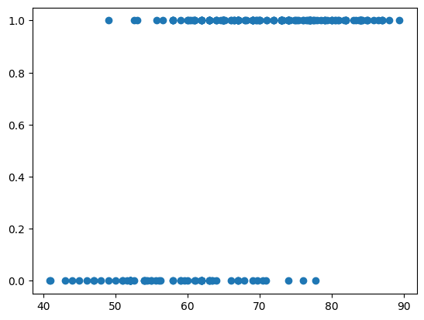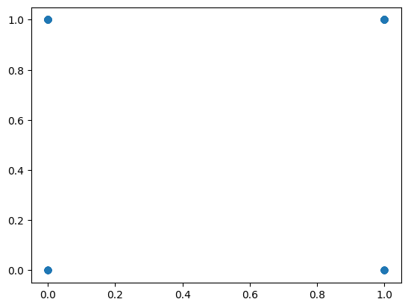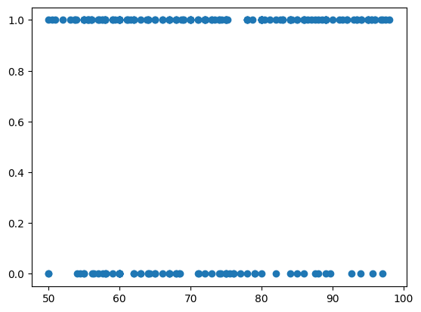

Figure Model Result

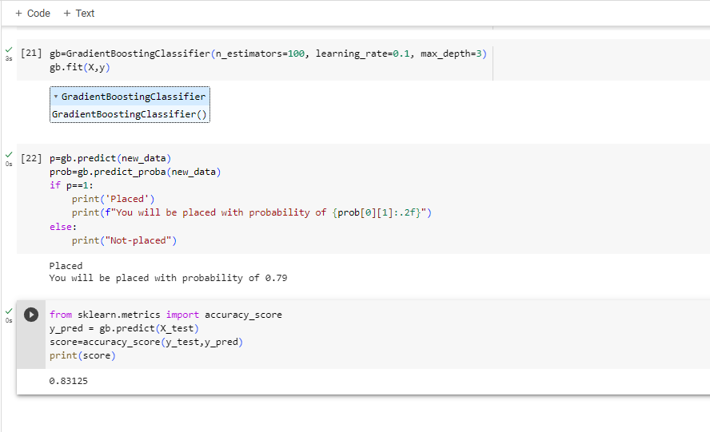

Figure Outlier Detection

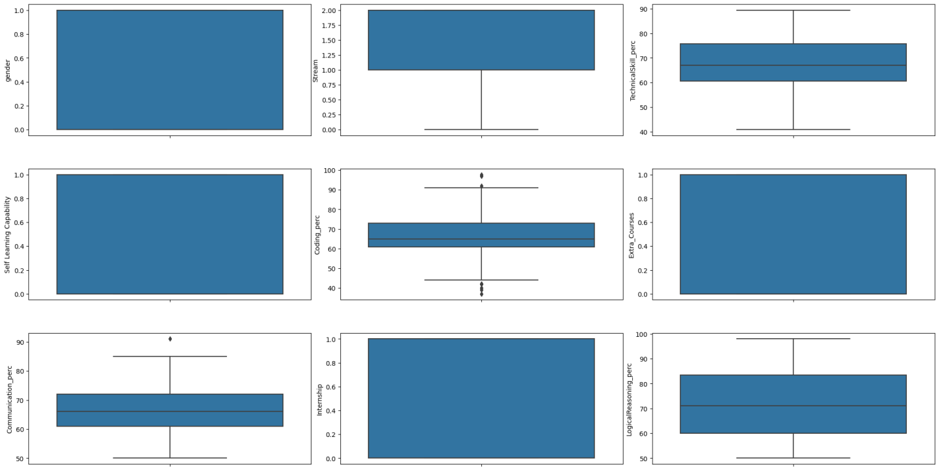

Figure Checking Feature Distribution

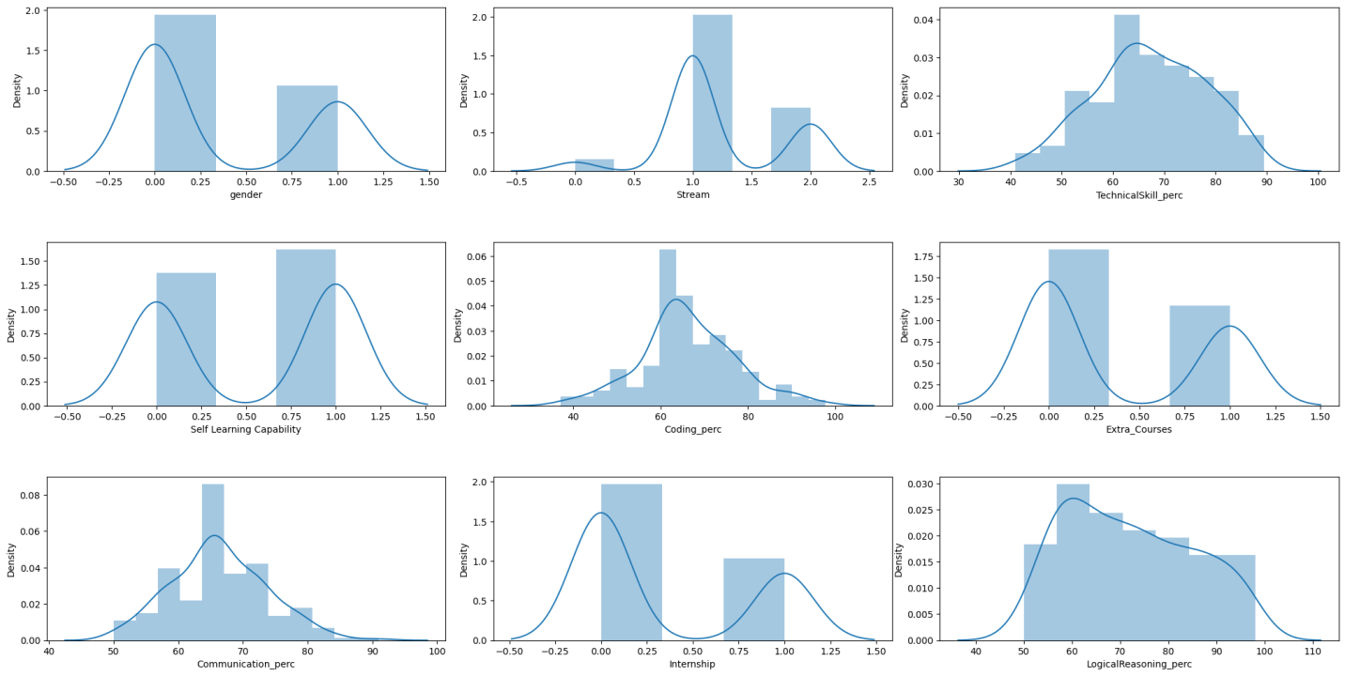

# Streamlit Code Result:

C:\Users\HYMAVATHI\Desktop\Mini Project\Code>streamlit run app.py

You can now view your Streamlit app in your browser.

Local URL: http://localhost:8501

Network URL: <http://192.168.227.215:8501>

Figure GUI Interface

